**2SD3 Assignment 2**

Rochan Muralitharan – muralr3

1. A)

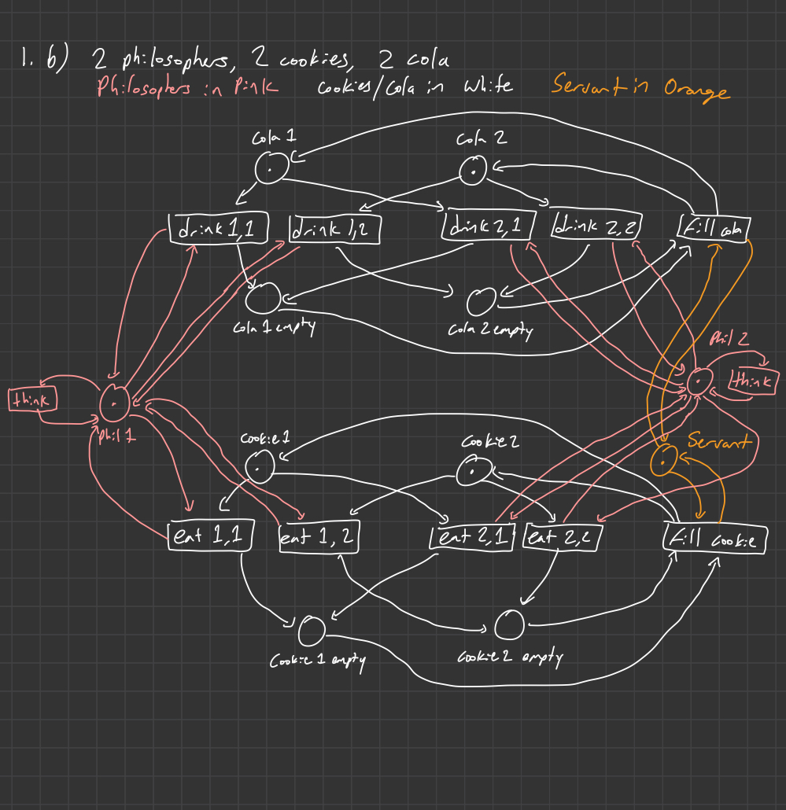

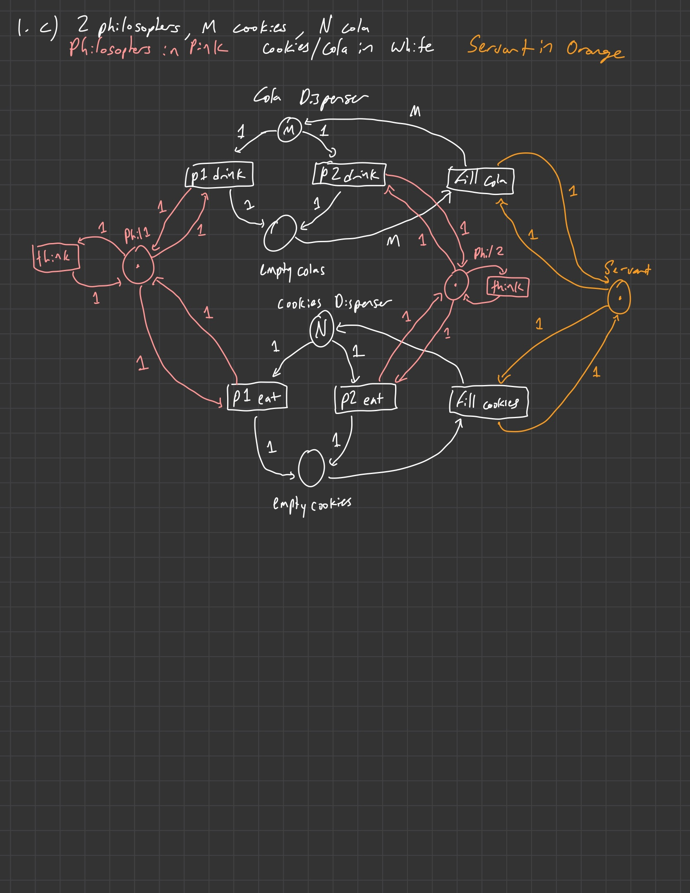

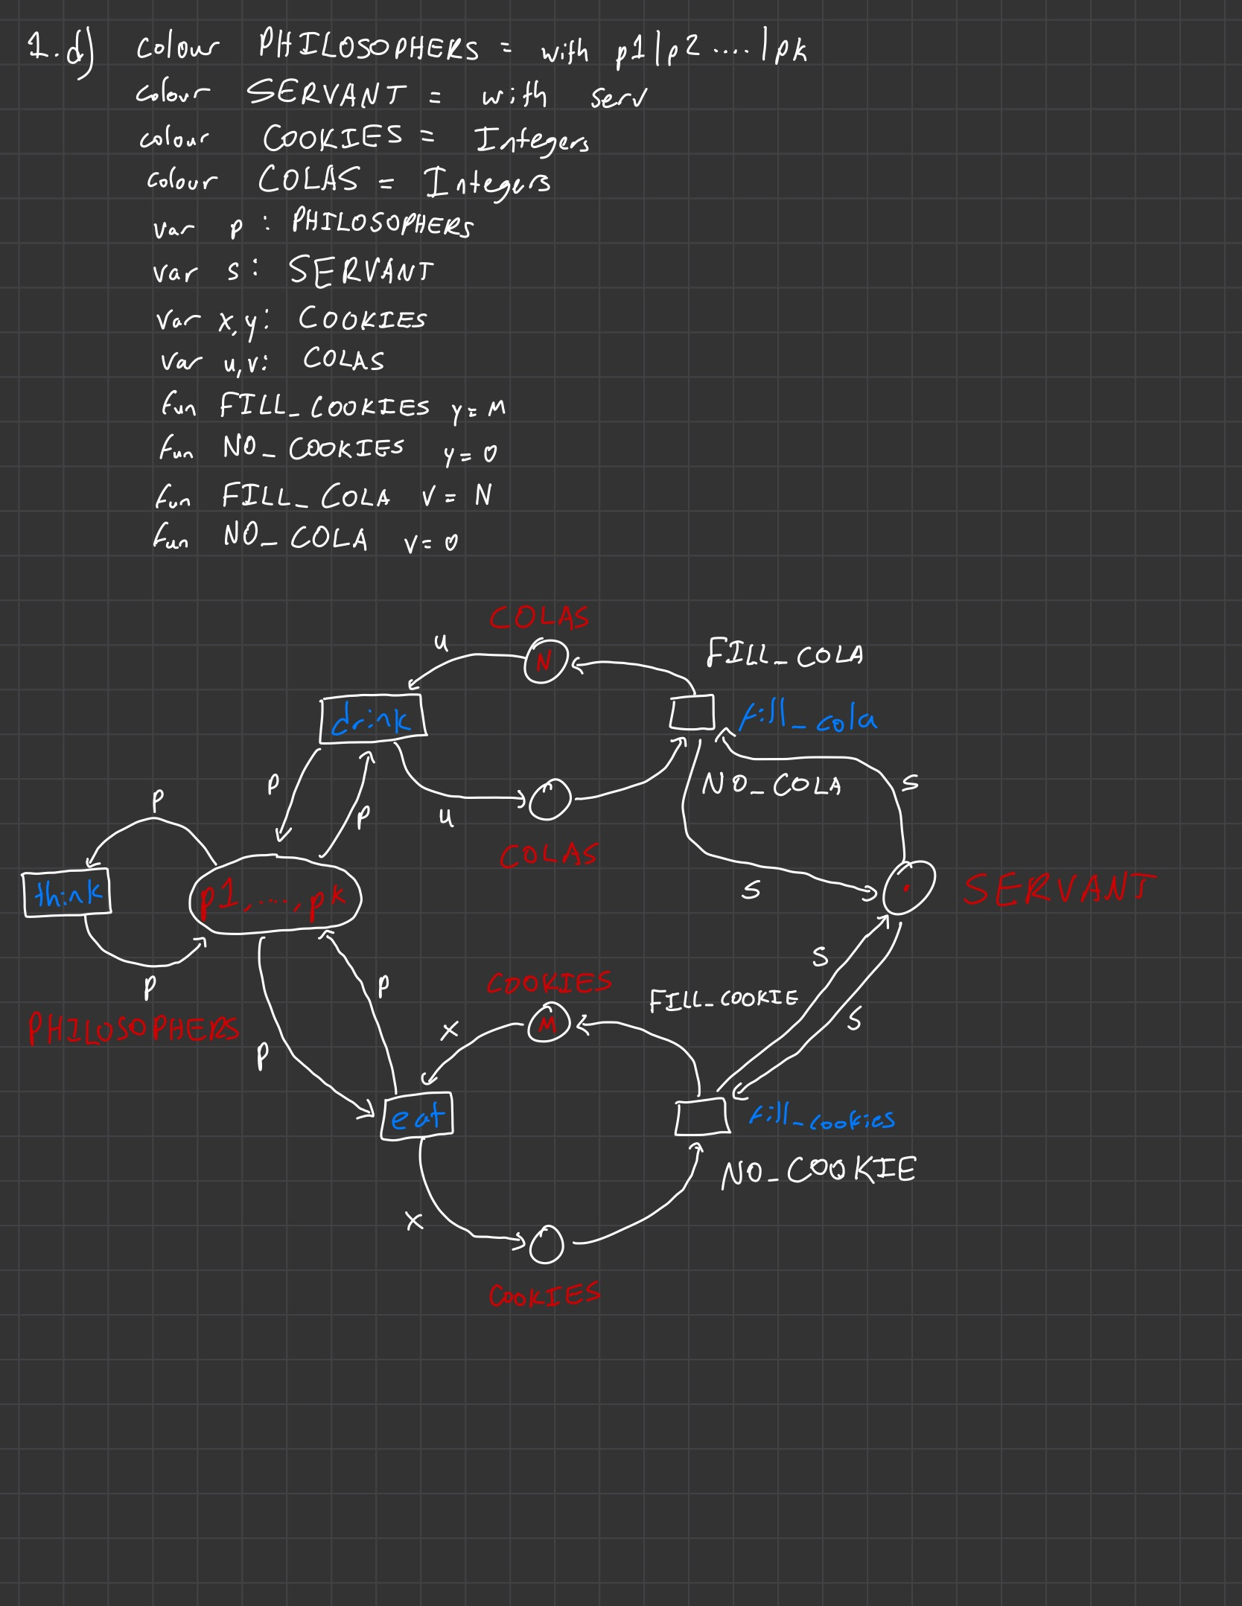

e) The first and most obvious difference between the FSP and the Petri Nets is that the FSP is an algebraic display of the process while the Petri Nets are a visual display of the process. The elementary petri net is a good way to show every single process and state, however it gets confusing when there are a lot of processes/states, so for my elementary petri net I used 2 philosophers and a capacity of 2 for both dispensers. The place/transition net condenses the number of transitions making it less complex than the elementary petri net. This net allows us to show a larger number of processes. For my place transition petri net, I used 2 philosophers. Coloured Petri nets are also less complex than elementary petri nets, but also can use 1 state to represent multiple states, which for in our case would be philosophers. The coloured petri net represent *k* philosophers with one state.

f) In Java File *Philosophers_A2_Q1.java*

2 Philosophers, capacity for both dispensers is 2

1. A)

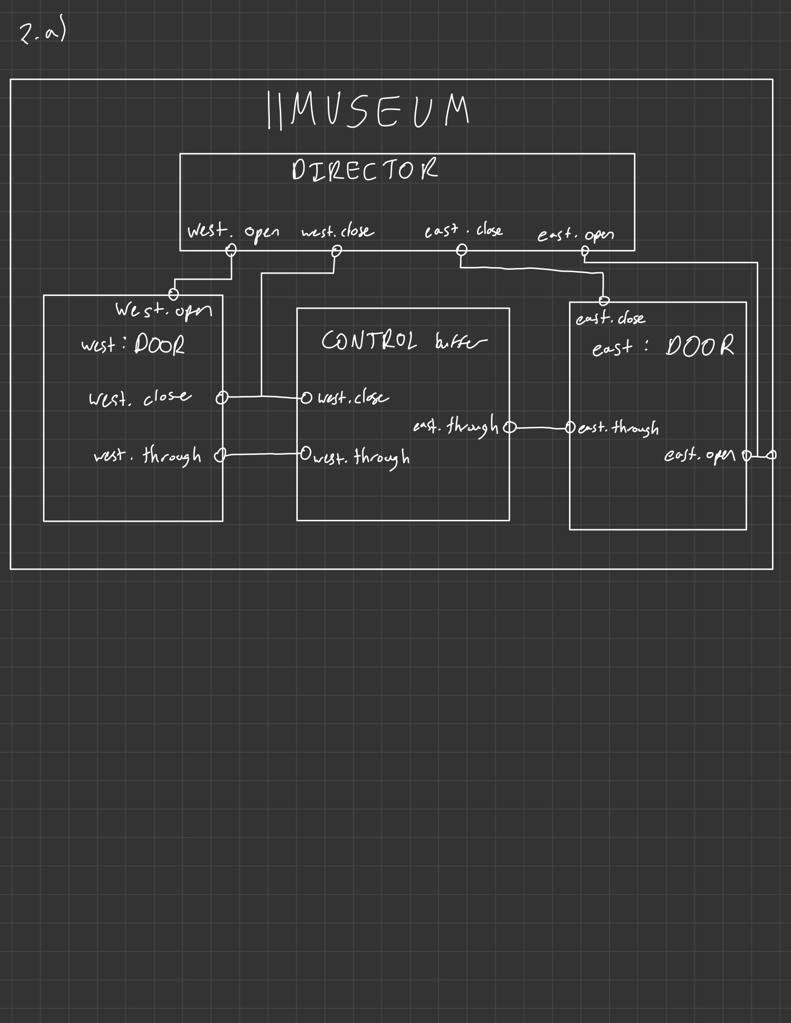

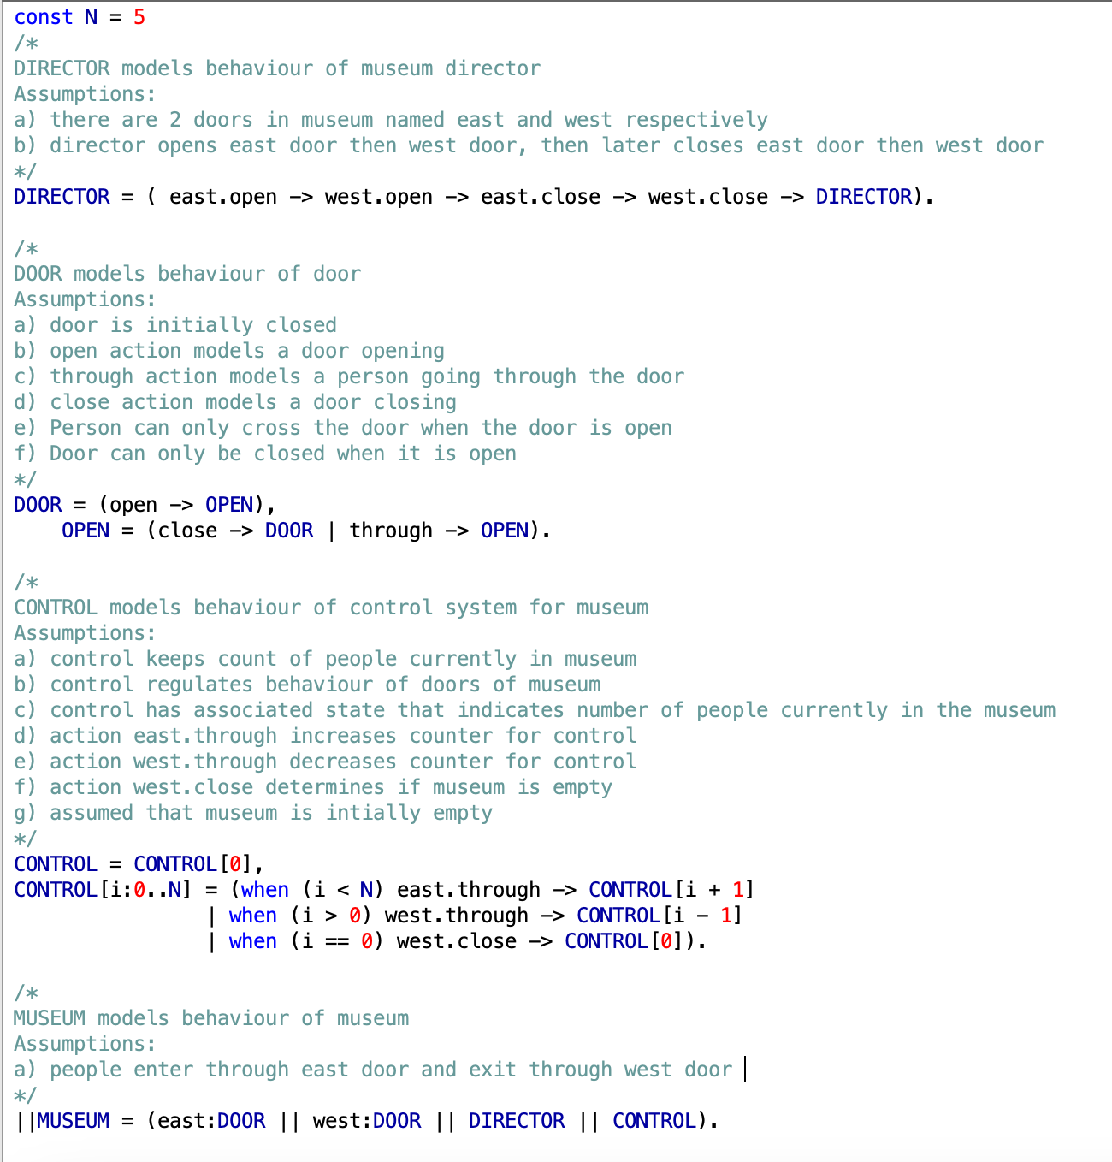

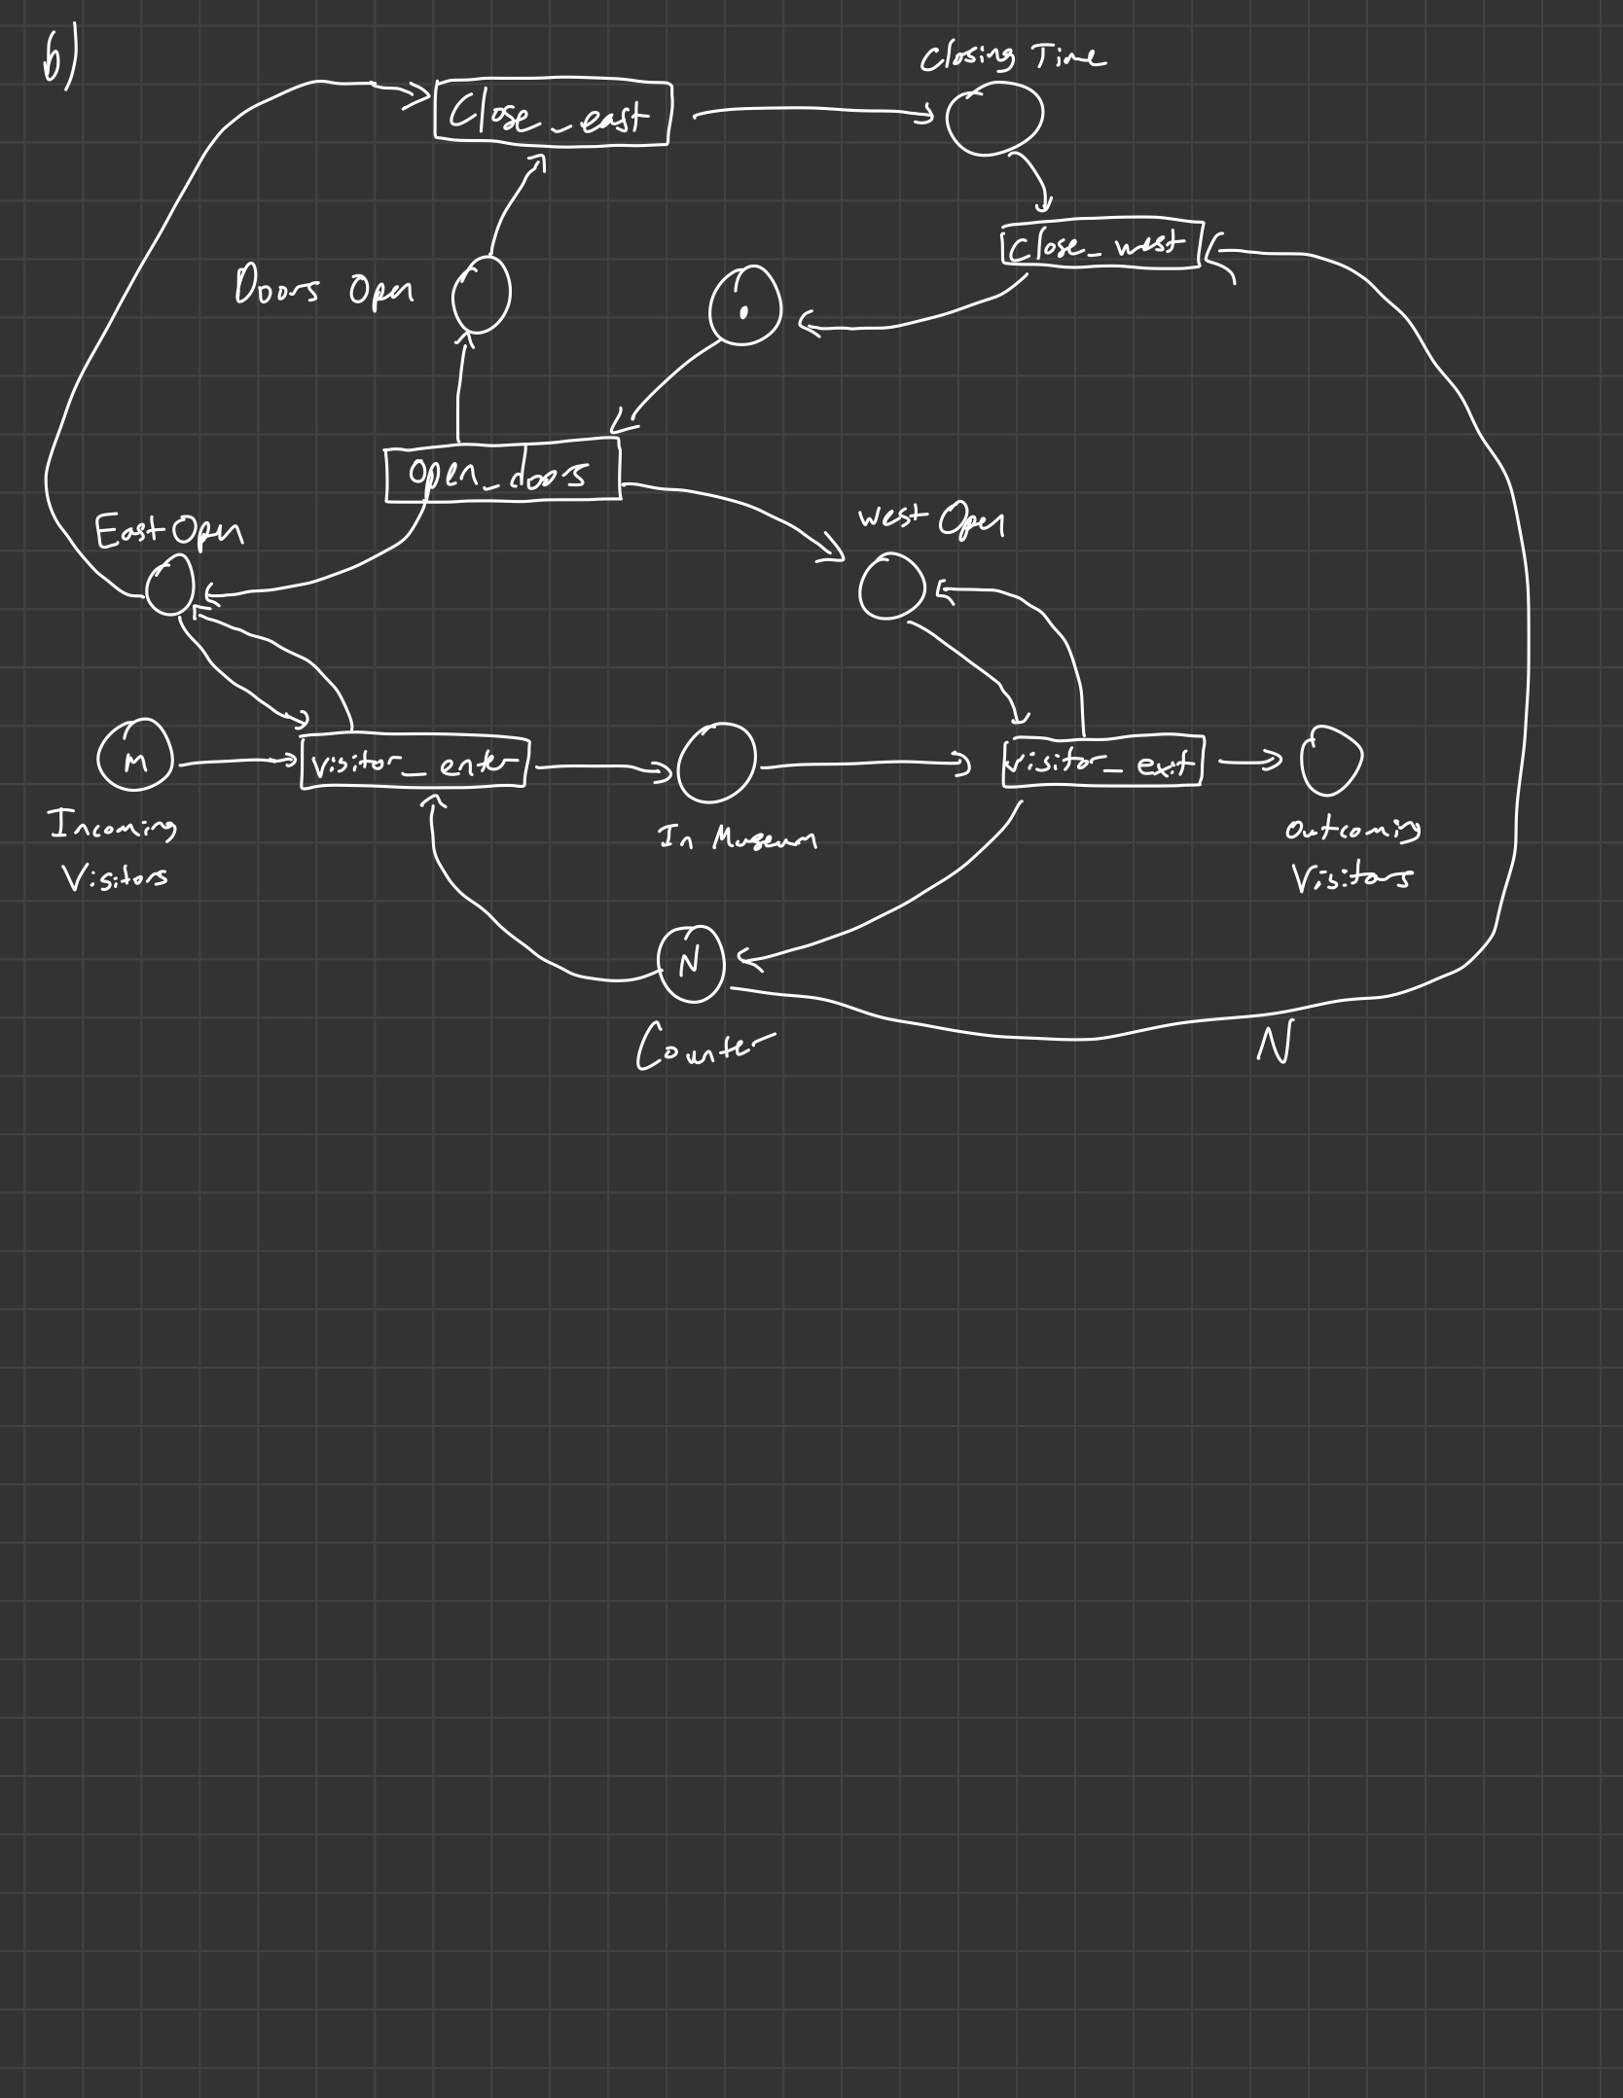

c) In Java File *Museum_A2_Q2.java*

1. Graphical user interface, text, application

   Description automatically generated

Starvation won’t happen when car departure has lower priority than car arrival.

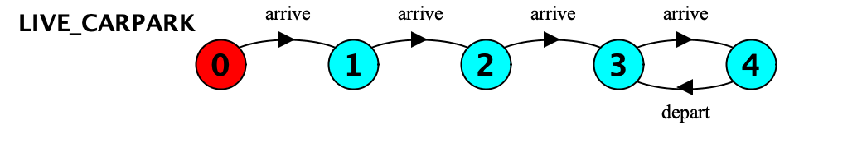

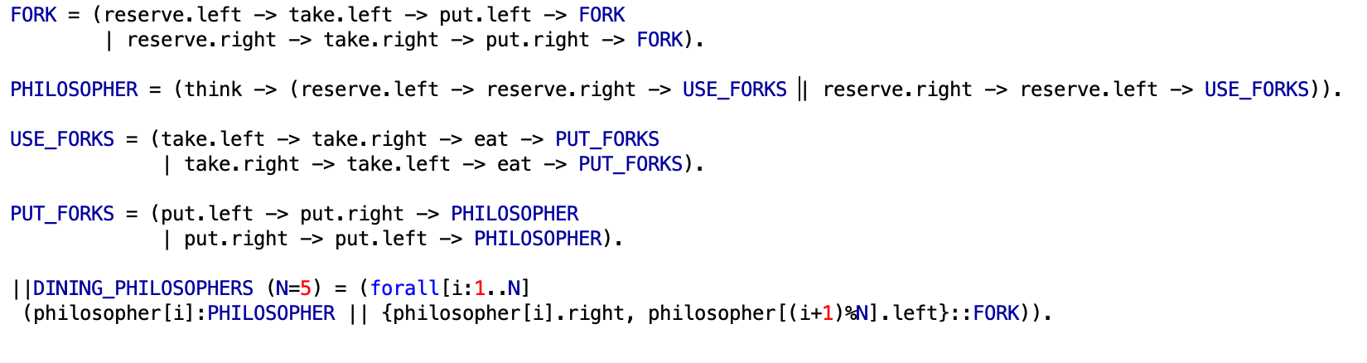

1. 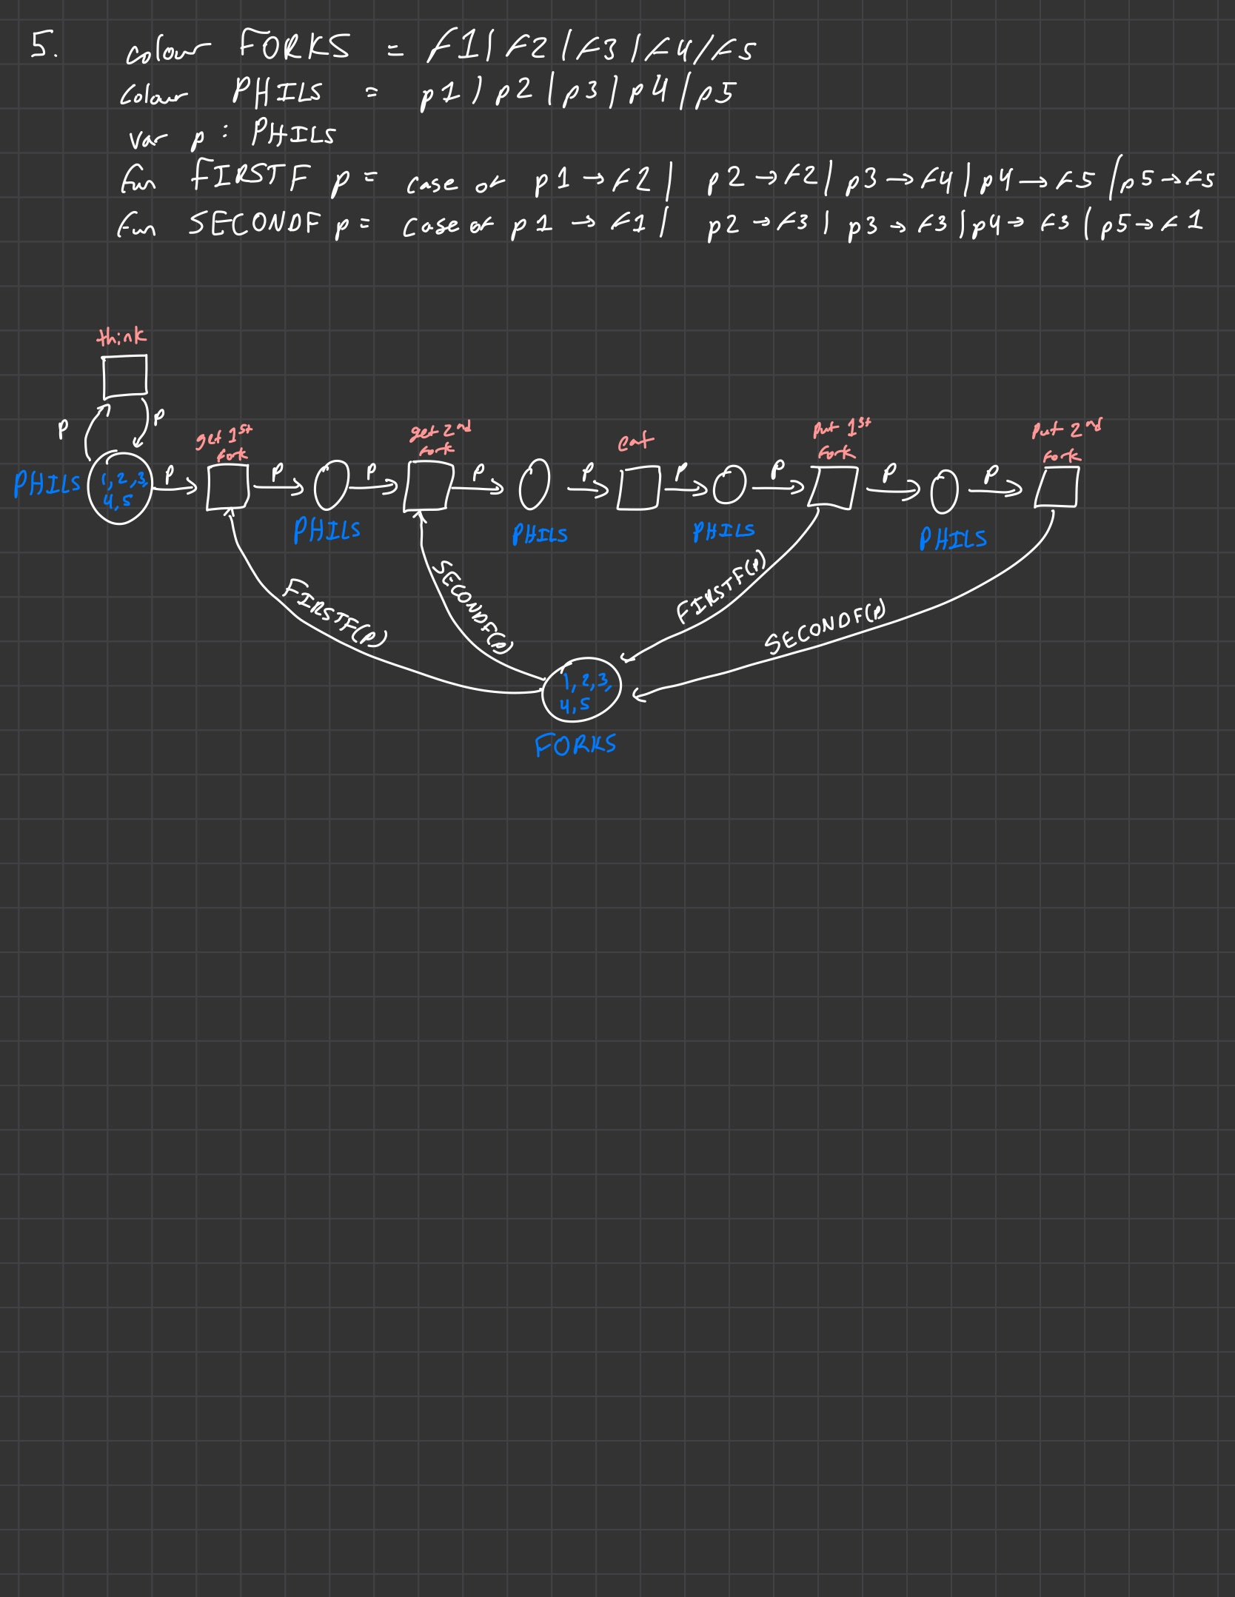
2. 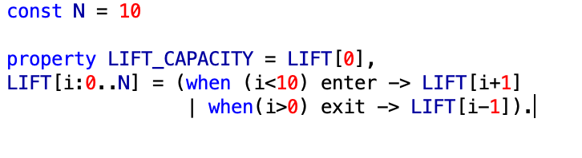

1. Diagram, venn diagram

   Description automatically generated

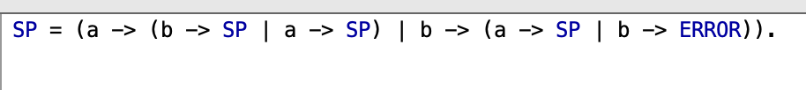

1. A)Graphical user interface, text, application

   Description automatically generated

b)

